Date: 2.08.2026
Review- 0

Title: Intelligent Vehicle Assistance During Disasters
Team Members:
Name | Roll number
- K.Rahul | 2420030011
- B.Nagaraju | 2420030614
- Anudeep | 2420030148

Applications
- AI-based hazard detection: A YOLOv11 computer vision model identifies and draws bounding boxes around road hazards such as floods, fires, smoke, stranded persons, and vehicles from driver-uploaded or live camera images.
- Predictive road safety analytics: An XGBoost classifier evaluates rainfall, traffic level, and water level to categorize road conditions as Safe, Risky, or Blocked, producing risk scores and driving recommendations.
- Emergency SOS & interactive mapping: A one-click SOS feature shares GPS coordinates and hazard type, feeding a live Leaflet map showing disaster locations, safe routes, and nearby hospitals or shelters.
- Centralized monitoring: A role-based admin dashboard lets responders track live SOS feeds, manage drivers, and analyze disaster statistics through charts.
Limitations
- High dependency on quality, diverse annotated datasets covering varied geographies, lighting, and weather conditions.
- Model accuracy is still limited at an early training stage (67.8% precision, 61.2% recall over 5 epochs), so false negatives could route drivers through unsafe roads.
- Real-time inference and connectivity constraints on mobile/edge devices during disasters, when networks are often degraded.
- Privacy and regulatory concerns around continuous GPS tracking of drivers during SOS events.
Future Scope
- Multi-sensor fusion (satellite imagery, IoT flood sensors, LiDAR) to improve hazard detection accuracy beyond camera-only input.
- Federated learning to continuously improve models from crowd-sourced hazard reports while preserving driver privacy.
- Integration with smart-city and government disaster-response systems for coordinated relief operations.
- Predictive evacuation-route planning that combines live hazard feeds with traffic simulation for safer navigation.

4 Objectives:

- To develop a YOLOv11-based computer vision module that detects road hazards — floods, fires, smoke, stranded persons, and vehicles — from images in real time.
- To design an XGBoost-based predictive model that classifies road safety as Safe, Risky, or Blocked using rainfall, traffic level, and water level, and generates a risk score with driving recommendations.
- To build an interactive GPS-based SOS and mapping system that shows live disaster locations, safe routes, and nearby hospitals or shelters for drivers and responders.
- To implement a secure full-stack platform (FastAPI, React, MongoDB) with role-based authentication and an admin dashboard for centralized disaster monitoring and analytics.

Flow Chart of the Project:-

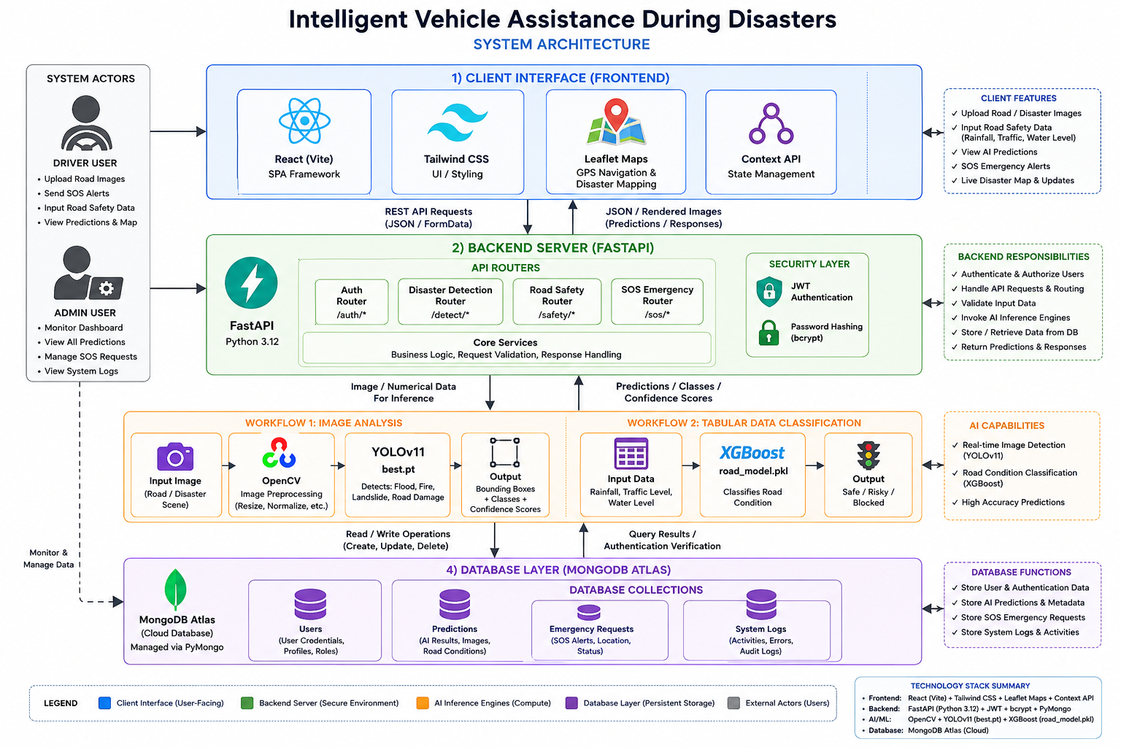

Methodology
The system architecture flowchart was developed using a layered architectural methodology based on the technical specifications of the Intelligent Vehicle Assistance During Disasters system.
- Component Identification
The system was first divided into its major components: React frontend, FastAPI backend, AI inference engines, and MongoDB Atlas database.
- Layered Architecture Design
The components were organized into four layers:
  - Client Interface: React (Vite), Tailwind CSS, Leaflet Maps, and Context API.

  - Backend Server: FastAPI with API routers, JWT authentication, and bcrypt password hashing.
  - AI Inference Engines: OpenCV, YOLOv11 for image-based disaster detection, and XGBoost for road-condition classification.
  - Database Layer: MongoDB Atlas managed through PyMongo.
- Data Flow Mapping
Arrows were used to represent communication between components:
  - Client ↔ Backend through REST API requests and JSON/FormData responses.
  - Backend → AI engines for image and numerical-data inference.
  - AI engines → Backend for predictions, classes, and confidence scores.
  - Backend ↔ Database for storing and retrieving system information.
- AI Processing Workflows
Two major AI workflows were represented:
  - Image Analysis: Road/disaster image → OpenCV preprocessing → YOLOv11 (best.pt) → detected classes, bounding boxes, and confidence scores.
  - Road Classification: Rainfall, traffic level, and water level → XGBoost (road_model.pkl) → Safe/Risky/Blocked classification.
- Security and Authentication Mapping
JWT authentication and bcrypt password hashing were included within the backend layer to show secure user authentication and authorization.
- Database Mapping
MongoDB Atlas collections were connected to the backend to store users, predictions, emergency SOS requests, and system logs.
- Visual Hierarchy and Styling
Different colors were assigned to each architectural layer to make the flowchart easy to understand:
  - 🔵 Blue — Client/Frontend
  - 🟢 Green — Backend
  - 🟠 Orange — AI/ML

  - 🟣 Purple — Database
  - ⚫ Gray — System Actors
- Final Refinement
Labels, arrows, technology names, model filenames, inputs, and outputs were refined so that the architecture diagram could independently communicate the complete system workflow.

